Lecture No.13 PARASITOLOGY DR. Raad H.H.
Phylum: Annelida Lamarck, 1809
introduction:
The annelids (also called Ringed Worm), collectively called Annelida (from French annelés "ringed ones", ultimately from Latin anellus "little ring", are a large phylum of segmented worms, with over 17,000 modern species including ragworms, earthworms and leeches.
They are found in marine environments, in freshwater, and in moist terrestrial environments. Although most textbooks still use the old division into polychaetes (almost all marine), oligochaetes (which include earthworms) and leech-like species, research since 1997 has radically changed in new scheme, viewing leeches as a sub-group of oligochaetes and then oligochaetes as a sub-group of polychaetes.
The basic annelid form consists of multiple segments, each of which has the same sets of organs and, in most polychaetes, a pair of parapodia that many species use for locomotion. Septa separate the segments of many species, but are poorly-defined or absent in some, The septa of these species also enable them to change the shapes of individual segments, which facilitates movement by peristalsis ("ripples" that pass along the body) or by undulations that improve the effectiveness of the parapodia.
Oligochaetes are full hermaphrodites and produce a ring-like cocoon round their bodies, in which the eggs and hatchlings are nourished until they are ready to emerge.
Annelids creep along or burrow by coordinating two sets of muscles. One set allows them to expand and anchor one part of their body while the other set contracts and pushes the rest of the body forward into the sediment. By alternating these two muscle sets, the worm can powerfully inch forward.
There are over 17,000 living annelid species, ranging in size from microscopic to the "Australian giant Gippsland earthworm", which can grow up to 3 metres (9.8 ft) long. Although research since 1997 has radically changed scientists' views about the evolutionary family tree of the annelids, most textbooks use the new classification into the following sub- classes (groups) :
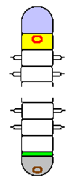
- Polychaetes (about 12,000 species). worms like Nereis .As their name suggests, they have multiple chetae ("hairs") per segment. Polychaetes have parapodia that function as limbs, and nuchal organs ("nuchal" means "on the neck") that are thought to be chemosensors. Most are marine animals, although a few species live in fresh water and even fewer on land.
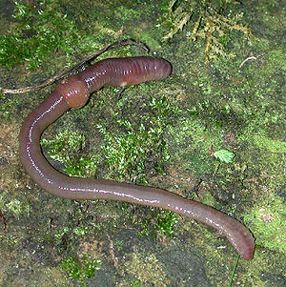
- Prostomium
- Peristomium
- O Mouth
- Growth zone
- Pygidium
O Anus

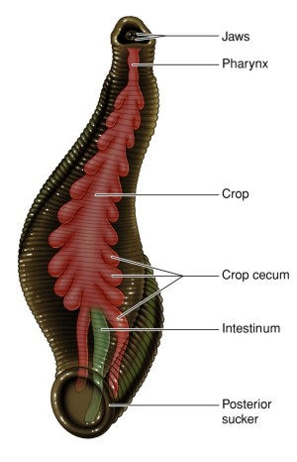
- Clitellates (about 5,000 species). These have few or no chetae per segment, and no nuchal organs or parapodia. However, they have a unique reproductive organ, the ring-shaped clitellum ("pack saddle") round their bodies, which produces a cocoon that stores and nourishes fertilized eggs until they hatch. The clitellates are sub-divided into :
  - Oligochaetes ("with few hairs"), which includes earthworms. "Lumbricus terrestris Oligochaetes have a sticky pad in the roof of the mouth. Most are burrowers that feed on wholly or partly decomposed organic materials.
  - Hirudinea, whose name means "leech-shaped" and whose best known members are leeches. Marine species are mostly blood-sucking parasites, mainly on fish, while most freshwater species are predators They have suckers at both ends of their bodies, and use these to move rather like inchworms ( caterpillars moth larvae).

Characters of Leeches
- The largest leech recorded till date measures about 16 inch in length. On an average, the size of leeches is between 7 - 80 mm.
- Like earthworms, leeches are hermaphrodites, meaning that a single leech has both male and female sexual organs.
- Leeches bite is painless, which is due to the anesthetic present in the saliva secretion of leeches.
- Leeches have the ability to feed in large amounts (about 5 times their body weight) and store nutrients for future use.
- Many leech species can survive for about one year after having a blood meal. They use the preserve food for survival.
- Some species (e.g hirudo) lays their young ones in cocoons, while others (e.g. Amazon leech) keep their babies (as much as 300) in the stomach.
- Accounts of the use of leeches for the medically suspected practise of blood-letting have come from China around 30 AD, India around 200 AD, ancient Rome around 50 AD and later throughout Europe. In the 19th century medical demand for leeches was so high that some areas' stocks were exhausted and other regions imposed restrictions or bans on exports, and "Hirudo medicinalis "is treated as an endangered species by both IUCN and CITES. More recently leeches have been used to assist in microsurgery, and their saliva has provided anti-inflammatory compounds and several important anticoagulants, one of which also prevents tumors from spreading.
